Use-Case Realization Report
DeleteUserAdministrator

Issue <1.0>
Revision History
Date | Issue | Description | Author
<dd/mmm/yy> | <x.x> | <details> | <name>

Table of Contents
1. Brief Description 4
2. Flow of Events 4
3. Interaction Diagrams 4
3.1 Collaboration Diagram for DeleteUserAdministrator 4
3.2 Sequence Diagram for DeleteUserAdministrator 5
4. Participating Objects 7
5. Class Diagrams 7
5.1 Class Diagram for DeleteUserAdministrator 7
6. Derived Requirements 7

Use-Case Realization Report
DeleteUserAdministrator

Brief Description

Flow of Events
[enter the flow of events here; you can use subsections to structure the text]

Interaction Diagrams

Collaboration Diagram for DeleteUserAdministrator
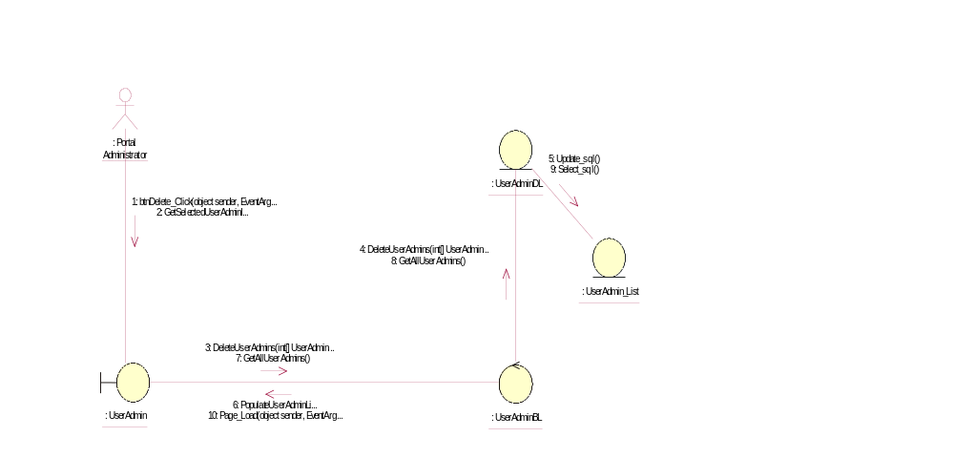

Sequence Diagram for DeleteUserAdministrator
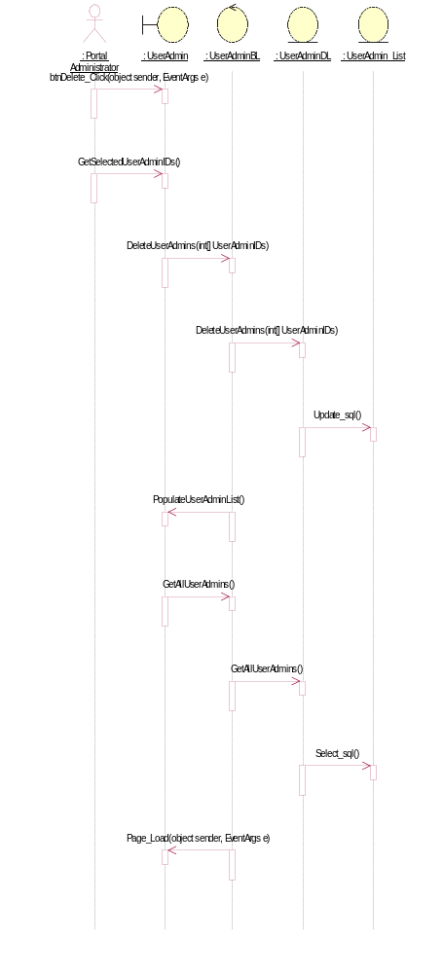

Participating Objects
: Portal Administrator

: UserAdmin

: UserAdmin_List

: UserAdminBL

: UserAdminDL

Class Diagrams

Class Diagram for DeleteUserAdministrator
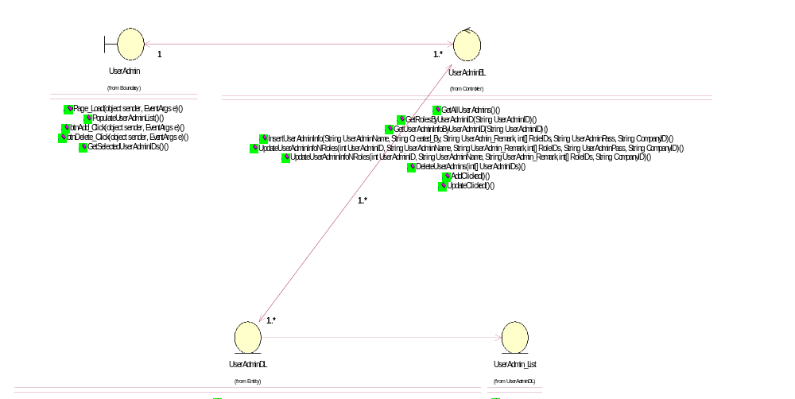

Derived Requirements
[enter the derived requirements here]

